LAB 6: ABSTRACT CLASS IN JAVA

Name: Shreyas Sawant Div: D7A Roll No.: 55

Q .1 Take a class called Figure consisting of abstract method area(). Inherit this figure class through various other classes like Circle, Rectangle and Triangle which will redefine the function called area() as per the required formula.

CODE:

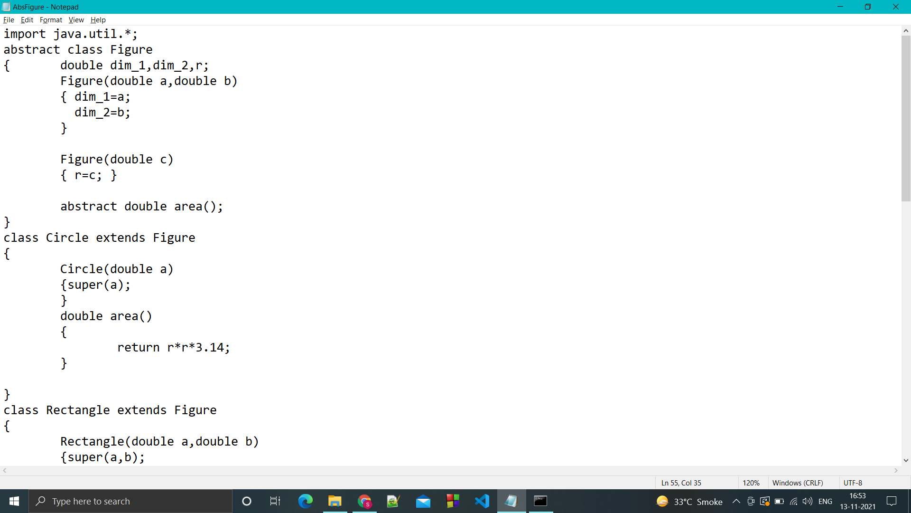

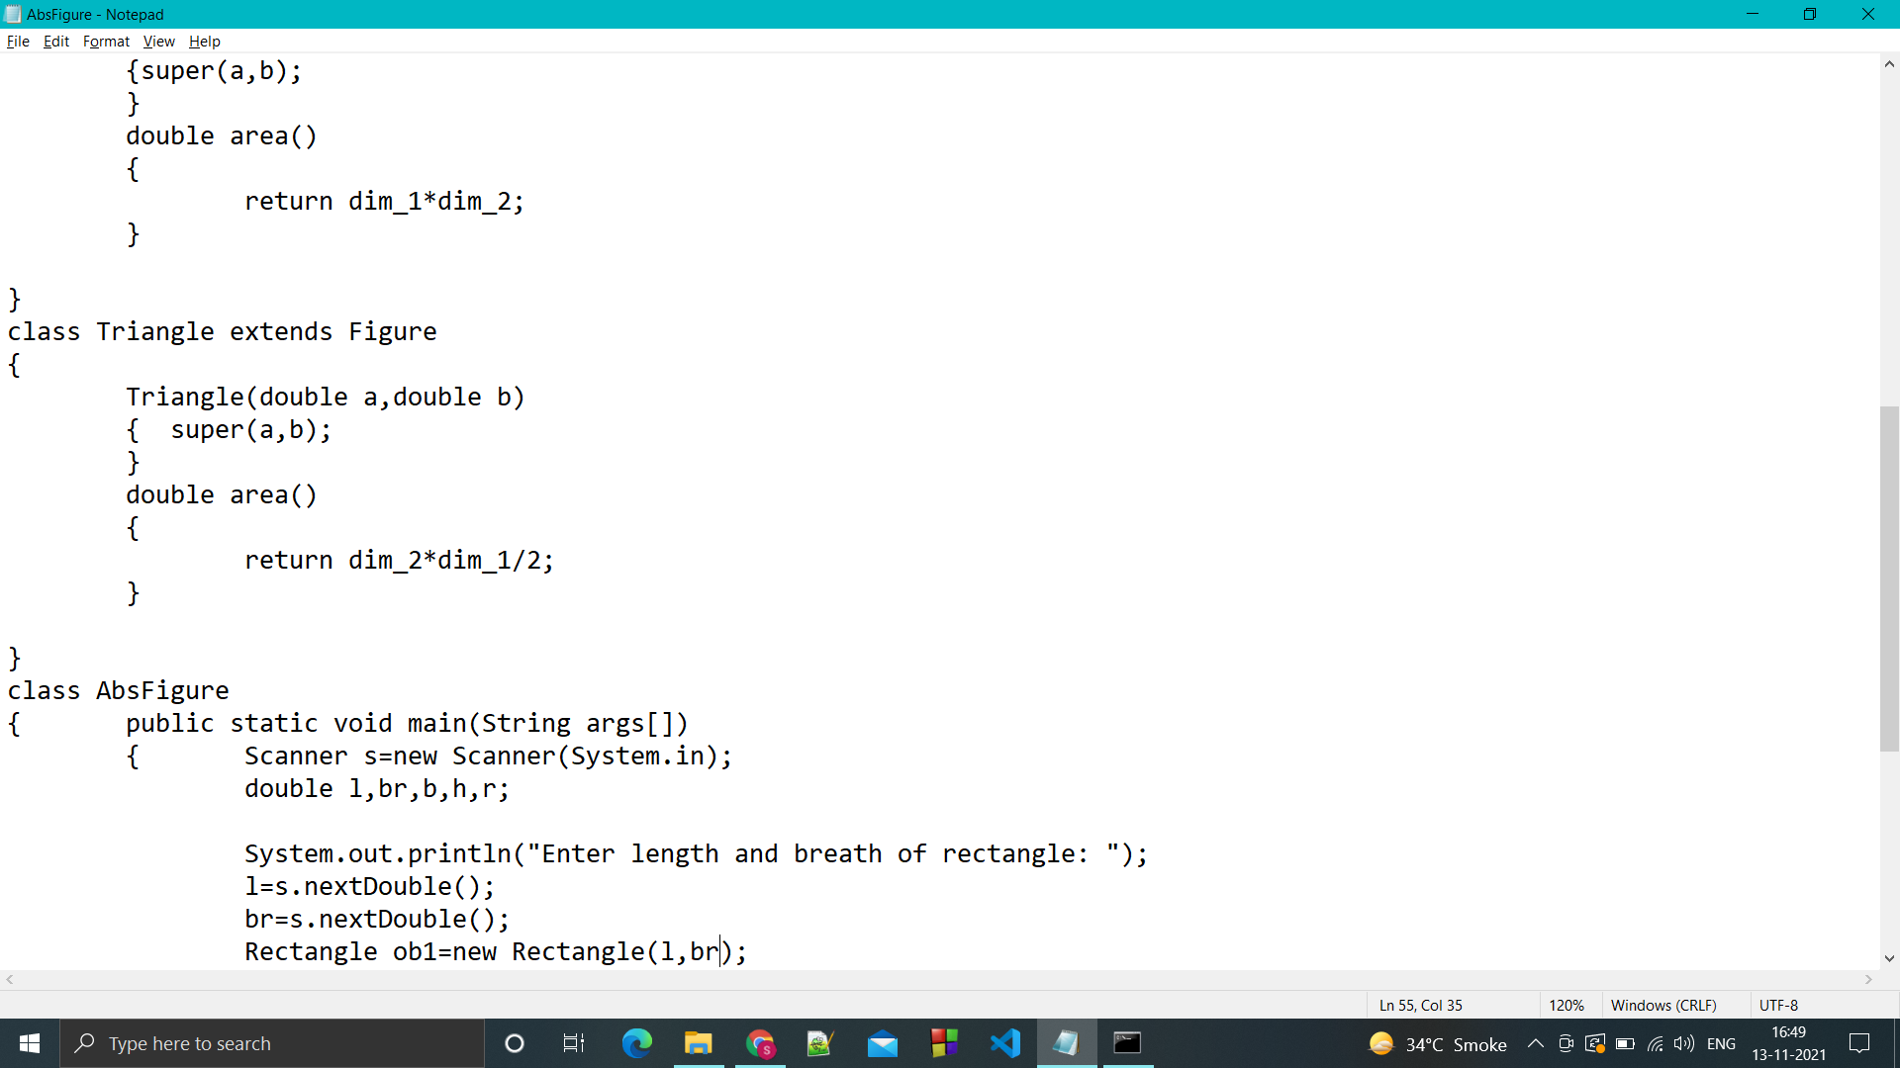

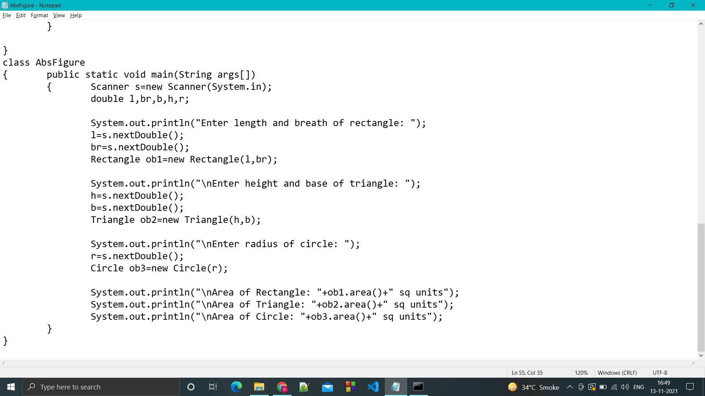

OUTPUT:

